
Chhatrapati Shahu Ji Maharaj University
Project Report

on
[MEALSTATION]

Submitted in Partial Fulfillment of the Requirements for the Degree of
Bachelors of Computer Application
By:
[Brajendra Singh]
[0302531]

Under the Supervision of
[Assi. Prof. Ms. Priti Mishra]
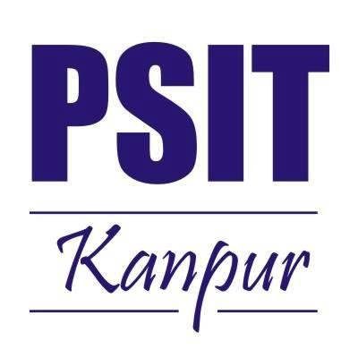
PSIT College of Higher Education

Kanpur-Agra-Delhi National Highway – 2, Bhauti, Kanpur
(2020-2021)

FORMAT OF THE PROJECT REPORT
- Certificate
- Declaration
- Acknowledgement
- Abstract

INDEX :

- Chapter-I:
- Introduction
- Existing System
- Problems in Existing System
- Proposed System
- Objective of the Project

- Chapter-II:
- Modules & Description of the Modules
- System Requirements
- Technology used in project

- Chapter-III:
- Feasibility Study
    - Software Development Life Cycle
    - Data Flow Diagram

- Chapter-IV:
- Data Base Schema Design
- Screen/Snap-Shots of the project

- Conclusion

- References

CERTIFICATE

This is to certify that project entitled “MEALSTATION” submitted for partial fulfillment of the degree of BCA under the Department of Bachelor of Computer Application to through PSIT College of Higher Education, Kanpur, done by Mr. Brajendra Singh, Roll No. 0302531 is an authentic work carried out by me under the guidance of Ms. Priti Mishra. The matter embodied in this project work has not been submitted earlier for award of any degree or diploma to the best of my knowledge and belief.

Internal Examiner/Guide External Examiner

Head of Department

Declaration

I hereby declare that the project entitled “MEALSTATION” submitted for the Bachelor of Computer Application degree is my original work and the project has not formed the basis for the award of any other degree of the university or other institute of higher learning, except where due acknowledgment has been made in the text.

Signature of the student

(Brajendra Singh)
(0302531)
BCA
PSIT College of Higher Education, Kanpur

ACKNOWLEDGEMENT

Presentation inspiration and motivation have always played a key role in the success of any venture.

I express my sincere thanks to Dr. APS Bhaudaria, Dean, PSIT College of Higher Education, Kanpur.

I pay my deep sense of gratitude to Mr. Santosh Kumar Sharma (HOD) of BCA Department, PSIT College of Higher Education to encourage me to the highest peak and to provide me the opportunity to prepare the project. I am immensely obliged to my friends for their elevating inspiration, encouraging guidance and kind supervision in the completion of my project.

I feel to acknowledge my indebtedness and deep sense of gratitude to my guide Ms. Priti Mishra whose valuable guidance and kind supervision given to me throughout the course which shaped the present work as its show.

Last, but not the least, my parents are also an important inspiration for me. So with due regards, I express my gratitude to them.

ABSTRACT

The purpose of Meal Station is to automate the existing manual system by the help of computerized
equipment’s and full-fledged computer software, fulfilling their requirements, so that their valuable
data/information can be stored for a longer period with easy accessing and manipulation of the same.
The required software and hardware are easily available and easy to work with.

Meal Station, as described above, can lead to error free, secure, reliable and fast management
system. It can assist the user to concentrate on their other activities rather to concentrate on the record
keeping. Thus it will help organization in better utilization of resources. The organization can maintain computerized records without redundant entries. That means that one need not be distracted by information that is not relevant, while being able to reach the information.

The aim is to automate its existing manual system by the help of computerized equipment’s and
full-fledged computer software, fulfilling their requirements, so that their valuable data/information can be stored for a longer period with easy accessing and manipulation of the same. Basically the project describes how to manage for good performance and better services for the clients.

Chapter-I:

- Introduction
- Existing System
- Problems in Existing System
- Proposed System
- Objective of the Project

Introduction

The “Meal Station” has been developed to override the problems prevailing in the practicing manual system. This website is supported to eliminate and in some cases reduce the hardships faced by this existing system. Moreover this system is designed for the particular need of the company to carry out operations in a smooth and effective manner.

The website is reduced as much as possible to avoid errors while entering the data. It also provides error message while entering invalid data. No formal knowledge is needed for the user to use this system. Thus by this all it proves it is user-friendly. Meal Station, as described above, can lead to error free, secure, reliable and fast management system. It can assist the user to concentrate on their other activities rather to concentrate on the record keeping. Thus it will help organization in better utilization of resources.

Every organization, whether big or small, has challenges to overcome and managing the information of Employee, Canteen, Stock, Customer, Sales. Every Canteen Management System has different Canteen needs, therefore we design exclusive employee management systems that are adapted to your managerial requirements. This is designed to assist in strategic planning, and will help you ensure that your organization is equipped with the right level of information and details for your future goals. Also for those busy executive who are always on the go, our systems come with remote access features, which will allow you to manage your workforce anytime, at all times. These systems will ultimately allow you to better manage resources.

Canteen management system is to provide fast services to their college students, Staffs etc. Usually, People have to go to canteen and order the foods and they have to wait in queue for a long time to get the orders, But with the help of this you just have to follow a very simple process to order your stuffs. And you need not to wait in the long queue. A canteen facility is a supplementary system that is provided by organizations for their employees/students. Organizations with large numbers of employees cannot handle a canteen with manual processes. Our canteen management system provides a friendly User Interface for numerous food outlets, menu design, billing features and lots more. Implementation of such a system makes the operation of the kitchen and the whole of the canteen as effective and quick as possible.

Meal Station, as described above, can lead to error free, secure, reliable and fast management
system. It can assist the user to concentrate on their other activities rather to concentrate on the record
keeping. Thus it will help organization in better utilization of resources. The organization can maintain computerized records without redundant entries. That means that one need not be distracted by information that is not relevant, while being able to reach the information.

Existing System

The existing system is a cash and paper-based system. The payment and process take a lot of time as the customer has to pay the exact amount and wait for the change. If the change is not available at the time, a coupon is provided which should be shown at the counter at the next purchase.

In the existing system only we have to go to canteen and or order the foods and we have to wait in queue for a long time to get the orders. This is the waste of time and energy.

The existing system is a cash and paper-based system. The payment and process take a lot of time as the customer has to pay the exact amount and wait for the change. If the change is not available at the time, a coupon is provided which should be shown at the counter at the next purchase.

Problems in Existing System

This system is generally advantageous for avoiding spending time waiting in the queue by posting orders directly to the kitchen without delay and also by scheduling orders ahead of time. It saves time and also the technique dealing with is easy. The proposed Canteen Management System is an adept solution for chaos at college canteens. Highlights of cloud for example auto-scaling, load adjusting and pay as you go improve the working of the system and to some extent unravel the motivation behind the proposed system.

Drawbacks of Existing System :

- Time Consuming
- Consumes large volume of pare work
- Needs manual calculations
- Don’t have exact food court record of each student
- Due to manual system there are chances of loss of some money
- To avoid all these limitations and make the working more accuracy the system needs to be computerized

Proposed System

The main aim of this project MealStation system is to provide fast services to their college students, Staff etc. Usually People have to go to canteen and order the foods and they have to wait in queue for along time to get the orders. But with the help of this you just have to follow a very simple process to order your stuffs. And you need not to wait in the long queue. This website will provide the list of different menu list with different categories. User can select any item from canteen and can order for it by using Pay on Delivery or can pay using QR Code embedded in the webpage

Expected Advantages of Proposed System.

- The system is very simple in design and to implement. The system requires very low system resources and the system will making almost all configurations. It has got following features
- Reduces wastage of food items
- Easy for calculating the exact of canteen vendor
- College authority can see the canteen’s income and total orders
- Ensure data accuracy
- Minimize manual data entry
- Greater efficiency

Objective of the Project

The main objective of the Meal Station is to manage the details of Canteen, Employee, Customer, Sales, Item, and Category. It manages all the information about Canteen, Stock, Item Category, and Canteen. The project is totally built at administrative end and thus only the administrator is guaranteed the access. The purpose of the project is to build an website to reduce the manual work for managing the Canteen, Employee, Stock, Customer. It tracks all the details about the Customer, Sales, Item, and Category.
The main objective of the project on canteen management system is to manage the details of Canteen, Students, Item, Stock.
The purpose of the project is to build an application program to reduce the manual work for managing the Canteen, Students, Customer, Item. It tracks all the details about the Item, Stock, Sales.

Functionalities provided by Canteen Management System are as follows:
- Provides the searching facilities based on various factors Such as Canteen, Item, Stock, Sales.
- Manage the information of Canteen, Stocks & also Students.
- Editing, adding and updating of Records is improved which results in proper resource management of Canteen data.
- Integration of all records of Sales.

Advantages of project
- Completely automated online ordering of food in a canteen.
- Order can be placed using personal android phones.
- Food ordering pages that look and feel exactly the same as the existing restaurant website.
- Food ordering pages hosted on secure and special server so no risk of customers getting redirected to servers where competitors’ websites are listed
- Developed using the latest website programming protocols for minimum server loads and ultra-fast loading and processing.
- Simple user-interface, Admin interface, Admin Panel for creation and configuration of menu groups, menu items, etc.
- Built-in facility to set modifiers on different menu items
- Facility to create modifier groups, individual modifier items and assign modifier item to different groups.
- Single and individual Admin Panel and login for each Canteen.
- Detailed summary of orders placed with option to search order, update order status, see orders, etc.
- Various reports to view total sale, details of registered members with facility to see report.

Chapter-II:

- Modules & Description of the Modules
- System Requirements
- Technology used in project

Modules & Description of the Modules

- CafeTeria Module: Used to managing website setting, database and url mapping. This module simple tell the types url or clicked button to redirected url are valid or invalid. It manages all the url or user end as well as admin end. It is responsible to redirecting to the use to the created url. The setting is manages by this modules also how much installed apps in your project, the template directory and the database connection engine, name, username, password, host, port etc. It also contains the validation setting of the user as well as admin. This is also manages the roots of the static files and the duplicate path of the static filed and the email smtp configuration how to sent reset password email to the admin and user in request.

- Carousel Module: Used to managing website banner which can be modified by the admin according to the need. The admin can modify the top images displaying in the website at the user end, he can simply put the latest thing available in the store or wishing the festival to the user of displaying any type of advertisement and giving the information to the user.

- Category Module: Used to managing the categories of the canteen which are available and admin can add, edit and delete the category. The manipulation of the category of the available item is totally at the admin hand, he can easy add the category if any new category item is introduced in the canteen.

- Customer Module: Used for managing the details of Customer. How the customer can register. What are the validation are required and password encryption. The validation of the not submitting the form empty or try to register with some empty field in the form and take care of the password entered by the user for maintaining the security and the transparency of the system. Use cannot register with same email id if he is already registered with before. If he forget the password he can simply put a request in the forget password section and an email will be sent to the registered email address is exist with the password reset instruction.

- Admin Module: Used for managing the information and details of admins. One admin can add another admin and can modify the privileges to access the data. This module is the backbone of the canteen management system because it has whole authority to create, view, update and delete the category as well as items. Admin can simply manage the order placed by the user. Admin can update the status of the order if it is ready or delivered or pending according to the need. Admin can also make the item available or unavailable if the item is out of stock. If the item is out of stock then user cannot place the order and if the item is available to the some user cart then he also cannot place the order.

- Item Module: Used for managing the Item details. Admin can add, update, delete the item and decide it is in stock or out of stock. The admin has authority to create view, update and delete the item according the need of the system. He can also change the status of the item if the item is not available to the canteen. For adding new item to the canteen admin need to go to the add item section available to the page and need to one image to display with the item and prices and availability of the item etc.

- Service Time Module: Used for managing the canteen open and close time details. Admin can add, update and remove the opening and closing time of the canteen. This module is basically if the admin does not want to user to place the order at some point of time then he can simply put the opening and closing time. The user can only place the order in the given time by the admin.

- Login Module: The login module help the user to log in the website. The use can view all the available item in the website but he cannot place any type of order if he is not logged in. If he try to log in first time then he firstly need to register to the website and provide his valid details. In this page the validation required at the login time is performed and take care of invalid credentials and empty values.

- Cart Module: This module is used to manage the card of the user who is currently logged in the system. If the user log out of the system then he cannot access the cart with out again logging in the system. This module is also take care of the total amount and listing the item in a tabular like format.

- Order Module: This module display the order of the user currency in the session or logged in the system. This module also displays the ordered item in the tabular like format so user can easily understand his orders

System Requirements

Hardware Requirements:
- Hard Disk : 50 GB or above
- Processor : Dual Core or above
- Processor Speed : 2.2 GHz
- Ram : 2GB
- Monitor : Display Panel (1024*76)

Software Requirements
- Operating System : Windows, Linux, Mac etc.
- Web Browser : Microsoft Edge, Mozilla Firefox, Chrome
- Fronted : HTML, CSS, Bootstrap
- Technology :- PYTHON 3, DJANGO 4.0.4
- Database Server :- My SQL [ 8.0.30]

Technology used in project

PYTHON :

Python is a high-level, general-purpose programming language. Its design philosophy emphasizes code readability with the use of significant indentation. Python is dynamically-typed and garbage-collected.

It supports multiple programming paradigms, including structured (particularly procedural), object-oriented and functional programming. It is often described as a "batteries included" language due to its comprehensive standard library.

Guido van Rossum began working on Python in the late 1980s as a successor to the ABC programming language and first released it in 1991 as Python 0.9.0.Python 2.0 was released in 2000 and introduced new features such as list comprehensions, cycle-detecting garbage collection, reference counting, and Unicode support. Python 3.0, released in 2008, was a major revision that is not completely backward-compatible with earlier versions. Python 2 was discontinued with version 2.7.18 in 2020.

Why

Python is omnipresent, and people use numerous Python-powered devices on a daily basis, whether they realize it or not. There are billions of lines of code written in Python, which means almost unlimited opportunities for code reuse and learning from well-crafted examples. What’s more, there is a large and very active Python community, always happy to help.

There are also a couple of factors that make Python great for learning:
- It is easy to learn – the time needed to learn Python is shorter than for many other languages; this means that it’s possible to start the actual programming faster;
- It is easy to use for writing new software – it’s often possible to write code faster when using Python;
- It is easy to obtain, install and deploy – Python is free, open and multiplatform; not all languages can boast that.

Programming skills prepare you for careers in almost any industry, and are required if you want to continue to more advanced and higher-paying software development and engineering roles. Python is the programming language that opens more doors than any other. With a solid knowledge of Python, you can work in a multitude of jobs and a multitude of industries. And the more you understand Python, the more you can do in the 21st Century. Even if you don’t need it for work, you will find it useful to know

DJANGO :

Django is a high-level Python web framework that encourages rapid development and clean, pragmatic design. Built by experienced developers, it takes care of much of the hassle of web development, so you can focus on writing your app without needing to reinvent the wheel. It’s free and open source.

Django is a Python-based web application framework that is free and open source. A framework is simply a collection of modules that facilitate development. They're grouped together and allow you to build apps or websites from scratch rather than starting from scratch.

"Rapid development and clean, pragmatic design" are key benefits of Django. When installed on a web server, the Django web framework can assist developers in quickly creating a feature-rich, secure, and scalable web front end.

For example, developers should not create their login screens or login processing. There are far too many possibilities for things to go wrong. Frameworks take care of this for you and handle all the tricky cases.

Built-in admin

Django has an in-built administration interface which lets you handle your models, user/ group permissions and to manage users. With model interface in place, there is no need for a separate database administration program for all but advanced database functions.

Features of Django
- Rapid Development
- Secure
- Scalable
- Fully loaded
- Versatile
- Open Source
- Vast and Supported Community

HTML :

HTML is an acronym which stands for Hyper Text Markup Language which is used for creating web pages and web applications. Let's see what is meant by Hypertext Markup Language, and Web page.

Hyper Text: Hyper Text simply means "Text within Text." A text has a link within it, is a hypertext. Whenever you click on a link which brings you to a new webpage, you have clicked on a hypertext. Hyper Text is a way to link two or more web pages (HTML documents) with each other.

Markup language: A markup language is a computer language that is used to apply layout and formatting conventions to a text document. Markup language makes text more interactive and dynamic. It can turn text into images, tables, links, etc.

Web Page: A web page is a document which is commonly written in HTML and translated by a web browser. A web page can be identified by entering an URL. A Web page can be of the static or dynamic type. With the help of HTML only, we can create static web pages

How HTML works

HTML is a text file containing specific syntax, file and naming conventions that show the computer and the web server that it is in HTML and should be read as such. By applying these HTML conventions to a text file in virtually any text editor, a user can write and design a basic webpage, and then upload it to the internet.

The most basic of HTML conventions is the inclusion of a document type declaration at the beginning of the text file. This always comes first in the document, because it is the piece that affirmatively informs a computer that this is an HTML file. The document header typically looks like this: <!DOCTYPE html>. It should always be written that way, without any content inside it or breaking it up. Any content that comes before this declaration will not be recognized as HTML by a computer.

Doctypes are not just used for HTML, they can apply to the creation of any document that uses SGML (Standard Generalized Markup Language). SGML is a standard for specifying a specific markup language being used. HTML is one of several markup languages that SGML and doctype declarations apply to.

CSS :

Cascading Style Sheets, fondly referred to as CSS, is a simple design language intended to simplify the process of making web pages presentable.

CSS handles the look and feel part of a web page. Using CSS, you can control the color of the text, the style of fonts, the spacing between paragraphs, how columns are sized and laid out, what background images or colors are used, layout designs,variations in display for different devices and screen sizes as well as a variety of other effects.

CSS is easy to learn and understand but it provides powerful control over the presentation of an HTML document. Most commonly, CSS is combined with the markup languages HTML or XHTML.

Why use CSS

These are the three major benefits of CSS:

1) Solves a big problem

Before CSS, tags like font, color, background style, element alignments, border and size had to be repeated on every web page. This was a very long process. For example: If you are developing a large website where fonts and color information are added on every single page, it will be become a long and expensive process. CSS was created to solve this problem. It was a W3C recommendation.

2) Saves a lot of time
CSS style definitions are saved in external CSS files so it is possible to change the entire website by changing just one file.

3) Provide more attributes
CSS provides more detailed attributes than plain HTML to define the look and feel of the website.

BOOTSTRAP :

Bootstrap is a free, open source front-end development framework for the creation of websites and web apps. Designed to enable responsive development of mobile-first websites, Bootstrap provides a collection of syntax for template designs.

As a framework, Bootstrap includes the basics for responsive web development, so developers only need to insert the code into a pre-defined grid system. The Bootstrap framework is built on Hypertext Markup Language (HTML), cascading style sheets (CSS) and JavaScript. Web developers using Bootstrap can build websites much faster without spending time worrying about basic commands and functions.

Bootstrap is the most popular HTML, CSS and JavaScript framework for developing a responsive and mobile friendly website.
- It is absolutely free to download and use.
- It is a front-end framework used for easier and faster web development.
- It includes HTML and CSS based design templates for typography, forms, buttons, tables, navigation, modals, image carousels and many others.
- It can also use JavaScript plug-ins.
- It facilitates you to create responsive designs.

Why use Bootstrap

Following are the main advantage of Bootstrap:
- It is very easy to use. Anybody having basic knowledge of HTML and CSS can use Bootstrap.
- It facilitates users to develop a responsive website.
- It is compatible on most of browsers like Chrome, Firefox, Internet Explorer, Safari and Opera etc.

What is a responsive website

A website is called responsive website which can automatically adjust itself to look good on all devices, from smart phones to desktops etc.
Scaffolding: Bootstrap provides a basic structure with Grid System, link styles, and background.
CSS: Bootstrap comes with the feature of global CSS settings, fundamental HTML elements style and an advanced grid system.
Components: Bootstrap contains a lot of reusable components built to provide iconography, dropdowns, navigation, alerts, pop-overs, and much more.
JavaScript Plugins: Bootstrap also contains a lot of custom jQuery plugins. You can easily include them all, or one by one.
Customize: Bootstrap components are customizable and you can customize Bootstrap's components, LESS variables, and jQuery plugins to get your own style.
What is Bootstrap 5?

Bootstrap is the newest and latest version of Bootstrap. It is the most popular HTML, CSS, JavaScript framework for developing responsive, mobile first websites.

MYSQL :

MySQL is a fast, easy-to-use RDBMS being used for many small and big businesses. MySQL is developed, marketed and supported by MySQL AB, which is a Swedish company. MySQL is becoming so popular because of many good reasons −

- MySQL is released under an open-source license. So you have nothing to pay to use it.
- MySQL is a very powerful program in its own right. It handles a large subset of the functionality of the most expensive and powerful database packages.
- MySQL uses a standard form of the well-known SQL data language.
- MySQL works on many operating systems and with many languages including PHP, PERL, C, C++, JAVA, etc.
- MySQL works very quickly and works well even with large data sets.
- MySQL is very friendly to PHP, the most appreciated language for web development.
- MySQL supports large databases, up to 50 million rows or more in a table. The default file size limit for a table is 4GB, but you can increase this (if your operating system can handle it) to a theoretical limit of 8 million terabytes (TB).
- MySQL is customizable. The open-source GPL license allows programmers to modify the MySQL software to fit their own specific environments

Chapter-III:

- Feasibility Study
    - Software Development Life Cycle
    - Data Flow Diagram

Feasibility Study

Feasibility study is made to see if the project on completion will serve the purpose of the organization for the amount of work, effort and the time that spend on it. Feasibility study lets the developer foresee the future of the project and the usefulness. A feasibility study of a system proposal is according to its workability, which is the impact on the organization, ability to meet their user needs and effective use of resources. Thus when a new application is proposed it normally goes through a feasibility study before it is approved for development.

A feasibility study is a comprehensive evaluation of a proposed project that evaluates all factors critical to its success in order to assess its likelihood of success. Business success can be defined primarily in terms of ROI, which is the amount of profits that will be generated by the project.
In a feasibility study, a proposed plan or project is evaluated for its practicality. As part of a feasibility study, a project or venture is evaluated for its viability in order to determine whether it will be successful.

As the name implies, a feasibility analysis is used to determine the viability of an idea, such as ensuring a project is legally and technically feasible as well as economically justifiable. It tells us whether a project is worth the investment—in some cases, a project may not be doable. There can be many reasons for this, including requiring too many resources, which not only prevents those resources from performing other tasks but also may cost more than an organization would earn back by taking on a project that isn’t profitable.

A well-designed study should offer a historical background of the business or project, such as a description of the product or service, accounting statements, details of operations and management, marketing research and policies, financial data, legal requirements, and tax obligations. Generally, such studies precede technical development and project implementation.

Software Development Life Cycle

The systems development life cycle (SDLC). Or software development process in systems engineering, information systems and software engineering, is a process of creating or altering information system, and the models and methodologies that people use to develop these systems. In software engineering, the SDLC concept underpins many kinds of software development methodologies. These methodologies from the framework for planning and controlling the creation of and information system: the software development process.

A System Development Life Cycle (SDLC) adheres to important phases that are essential for developers, such as planning, analysis, design, and implementation, and are explained in the section below. It include evaluation of present system, information gathering, feasibility study and request approval. A number of system development life cycle (SDLC) models have been created: waterfall, fountain, spiral, build and fix, rapid prototyping, incremental, and synchronize and stabilize. The oldest of these, and the best known, is the waterfall model: a sequence of stages in which the output of each stage becomes the input for the next. These stages can be characterized and divided up in different ways, including the following:

Systems analysis, requirements definition: Defines project goals into defined functions and operation of the intended application. Analyzes end-user information needs.

System Design: Describes desired features and operations in detail, including screen layouts, business rules, process diagrams, pseudo code and other documentation.

Development: The real code is written here.

Integration and testing: Brings all the pieces together into a special testing environment, then checks for errors, bugs and interoperability.

Acceptance, installation, deployment: The final stage of initial development, where the software is put into production and runs actual business.

Maintenance: What happens during the rest of the software’s life: changes, correction, additions, moves to a different computing platform and more, This is often the longest of the stages.

DESIGN:

Design is the first step into the development phase for any engineered product or system. Design is a creative process. A good design is the key to effective system. The term “design” is defined as “the process of applying various techniques and principles for the purpose of defining a process or a system in sufficient detail to permit its physical realization”. It may be defined as a process of applying various techniques and principles for the purpose of defining a device, a process or a system in sufficient details to permit its physical realization. Software design sits at the technical kernel of the software engineering process and is applied regardless of the development paradigm that is used. The system design develops the architectual detail required to build a system or product. As in the case of any systematic approach, this software too has undergone the best possible design phase fine turing all efficiency, perofrmance and accuracy levels. The design phase is a transition from a user oridented document to a document to the programmers or database personnel. System design goes through two phase of development: Logical and Physical Design

Data Flow Diagram

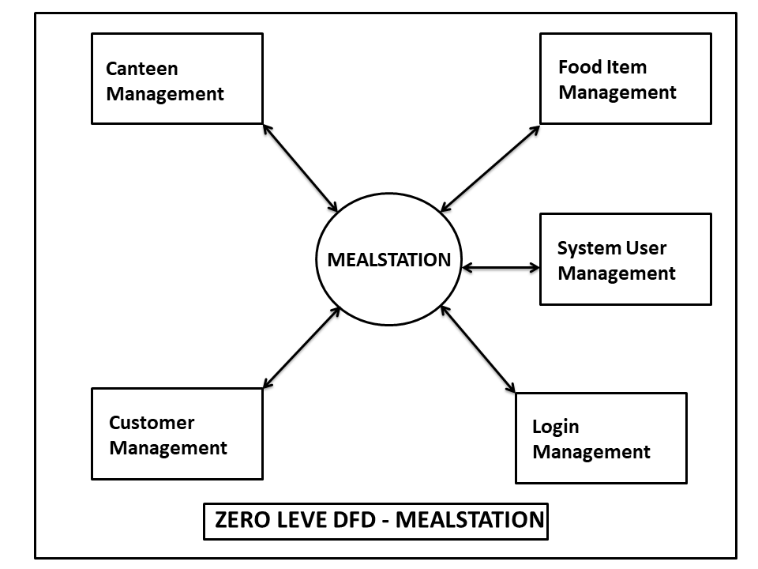

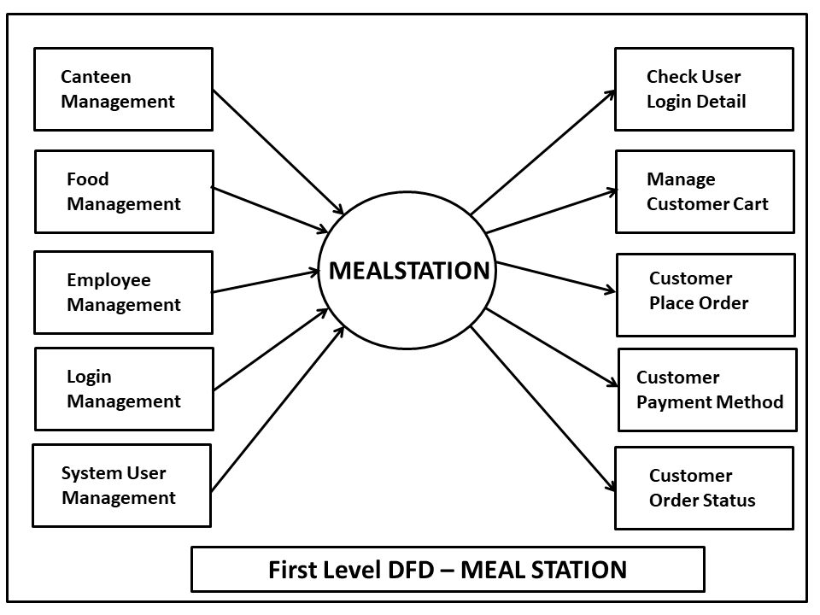

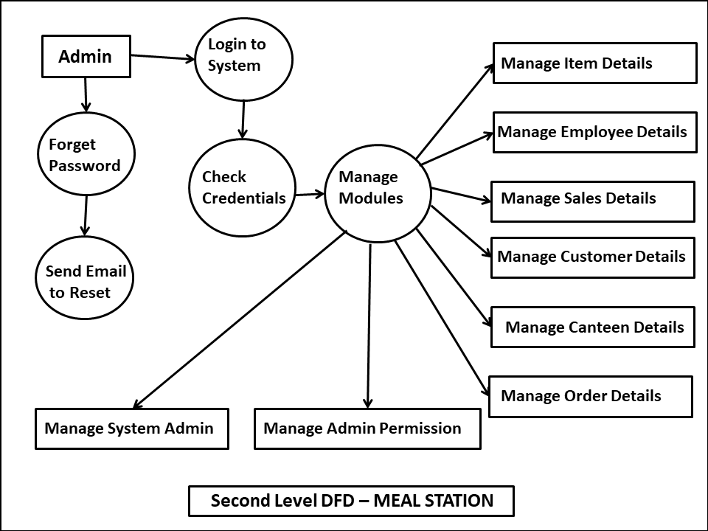

Chapter-IV:

- Data Base Schema Design
- Screen/Snap-Shots of the project
Data Base Schema Design

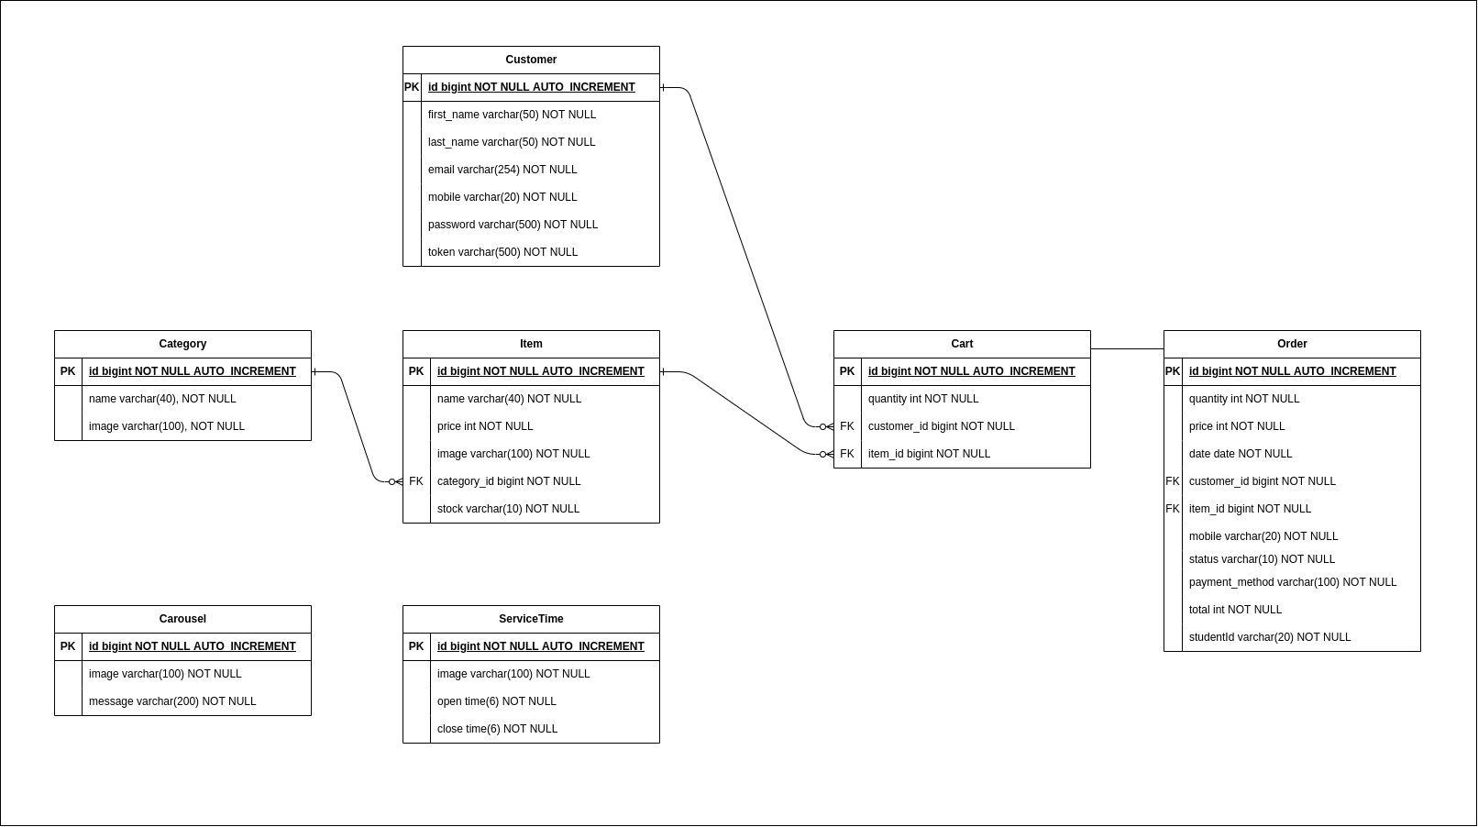

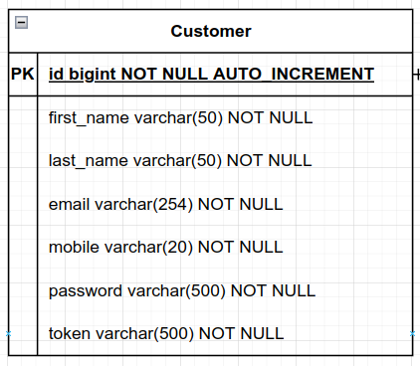

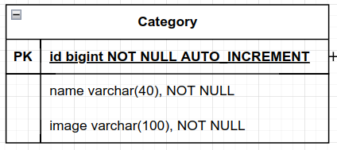
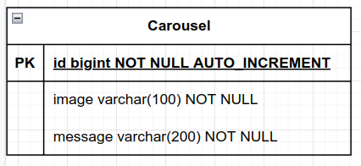
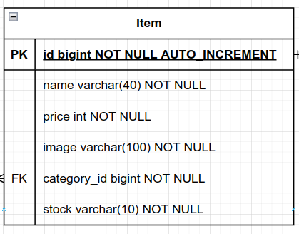
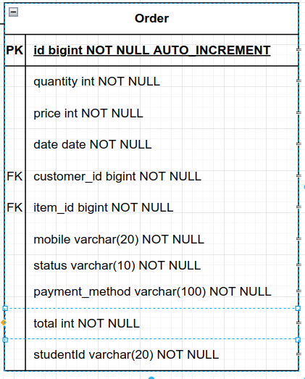
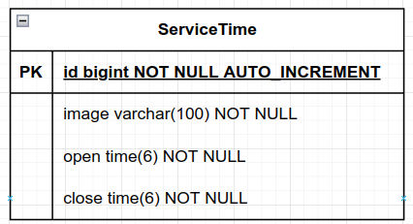
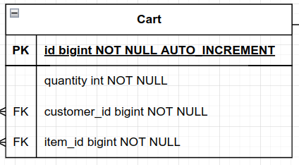

ER Diagram:

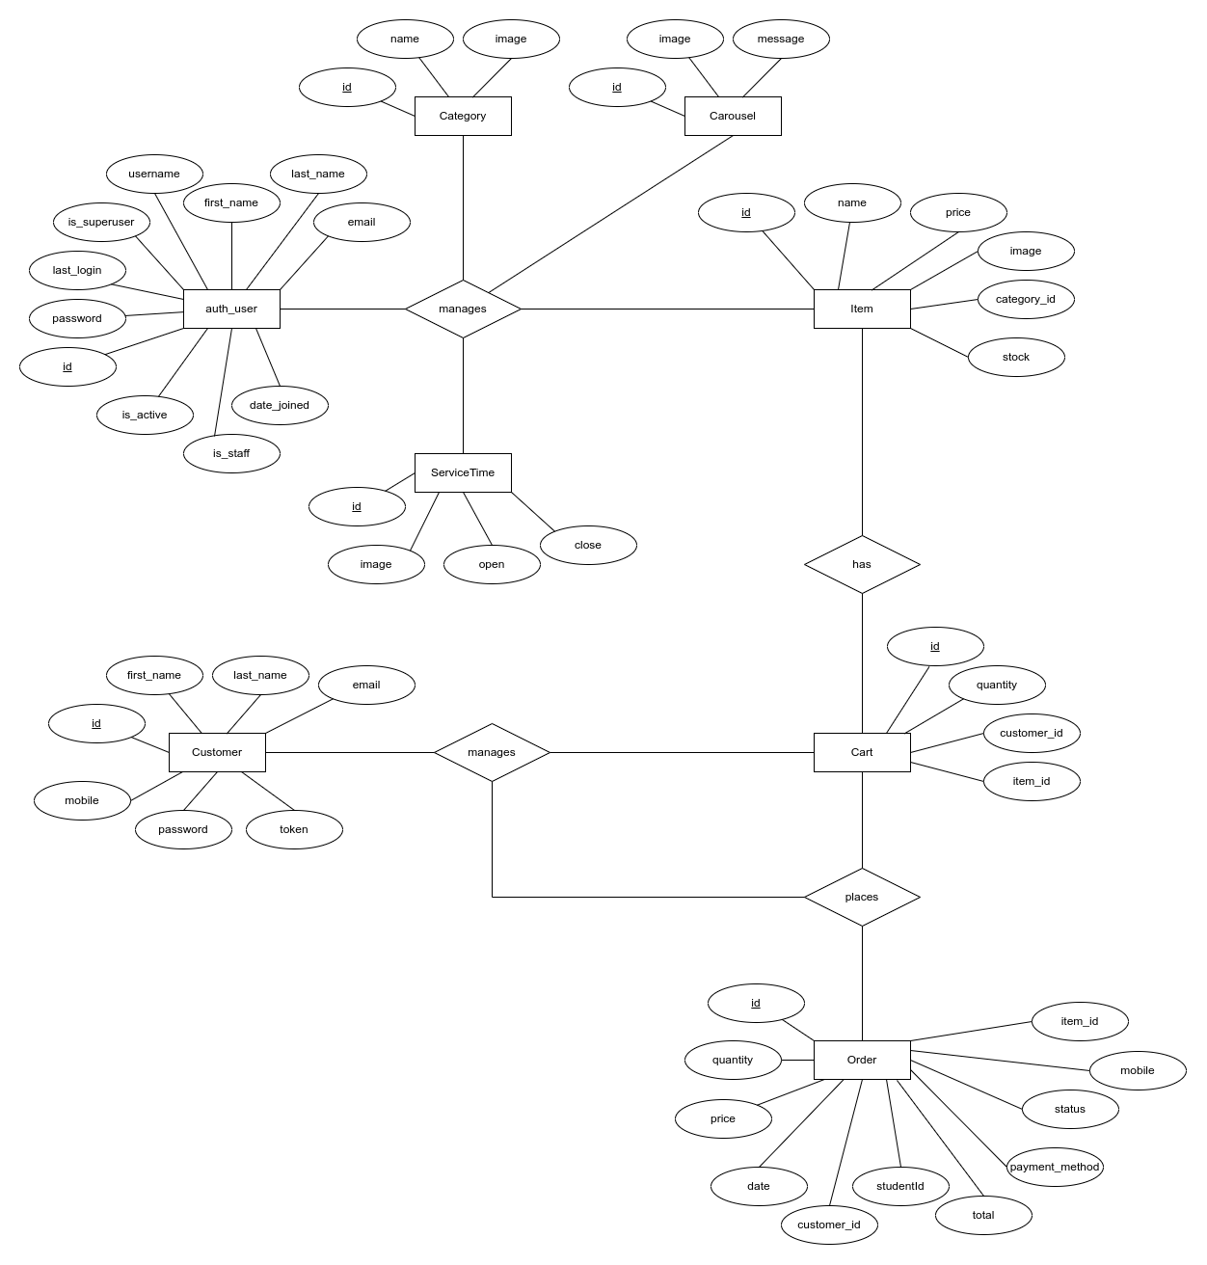

Screen/Snap-Shots of the project

Admin Area:
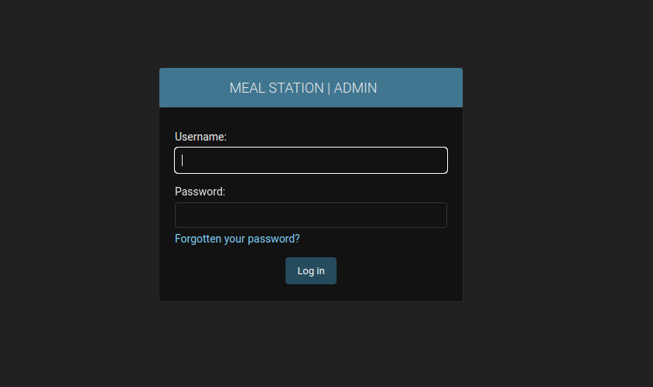
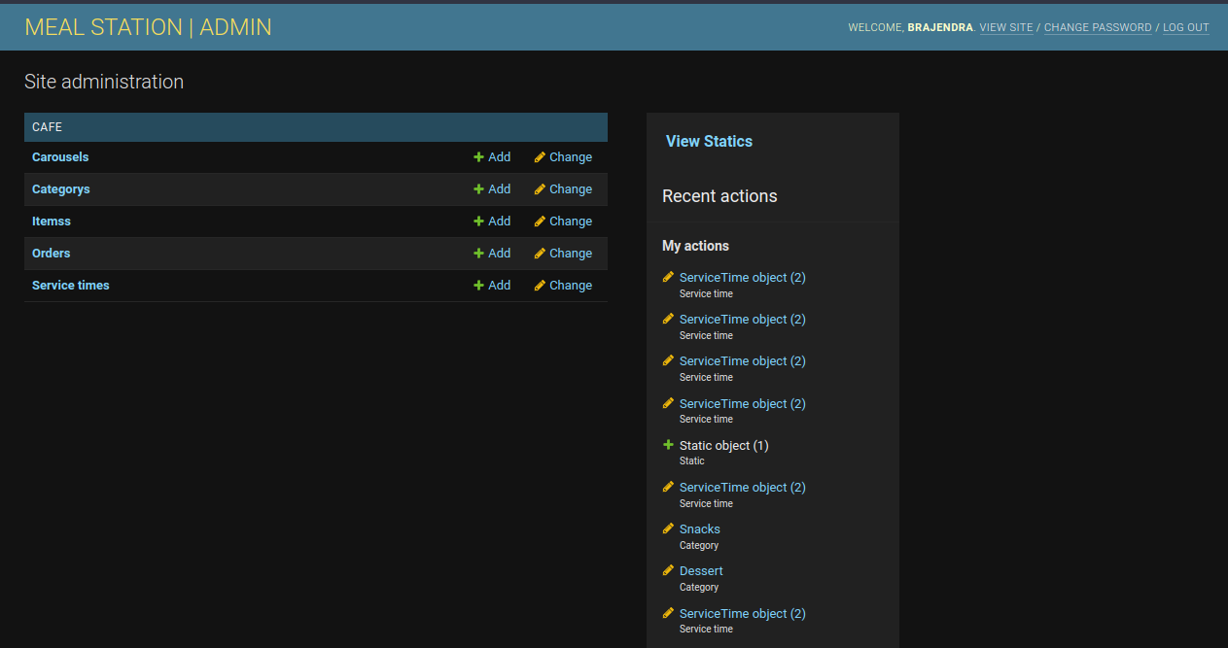
Dashboard:

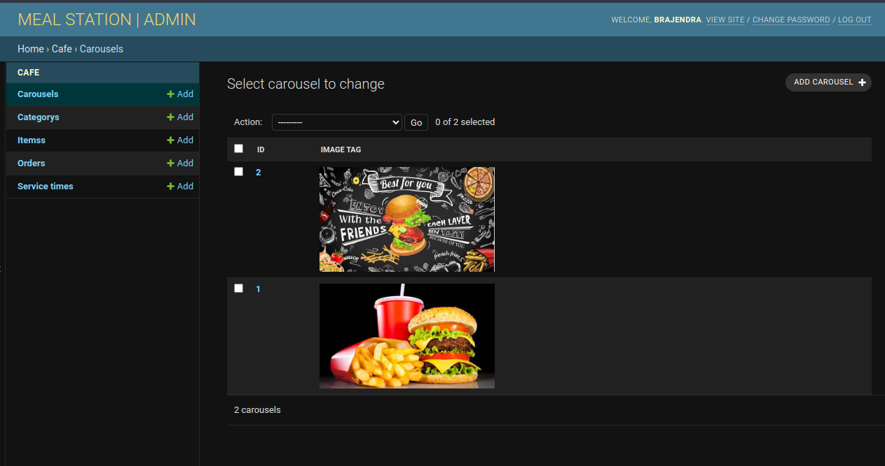
Carousel:

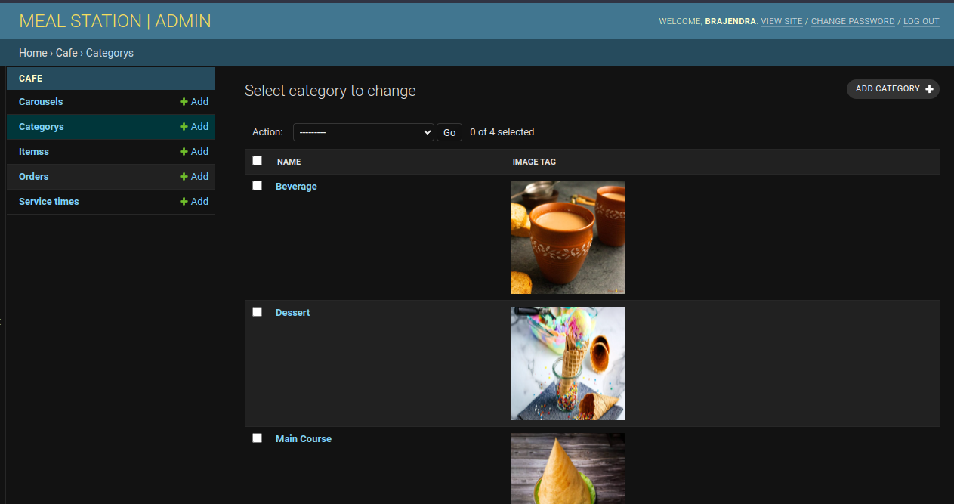
Category:
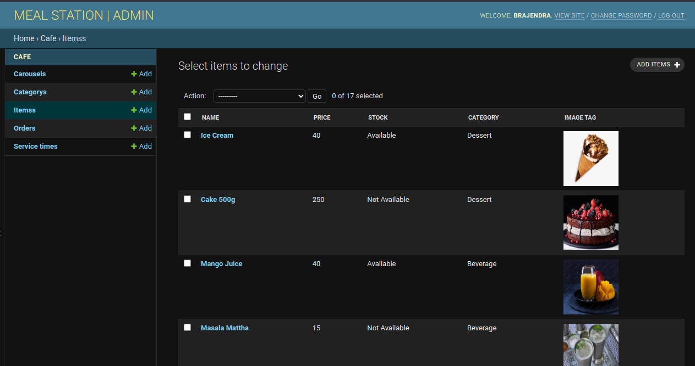
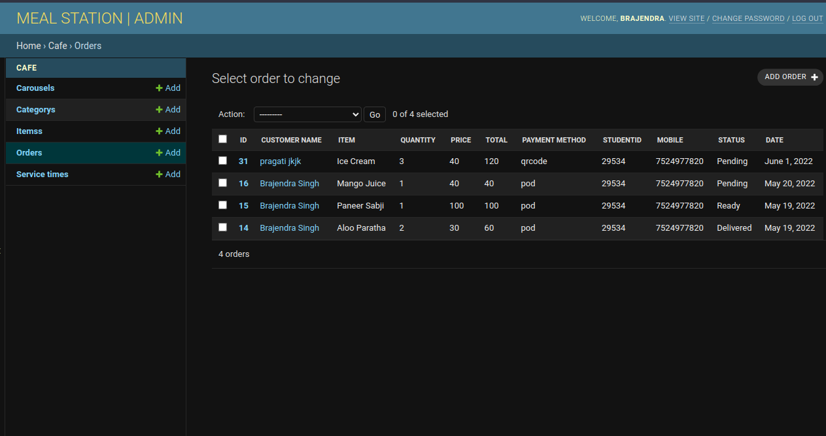
Items:

Orders:
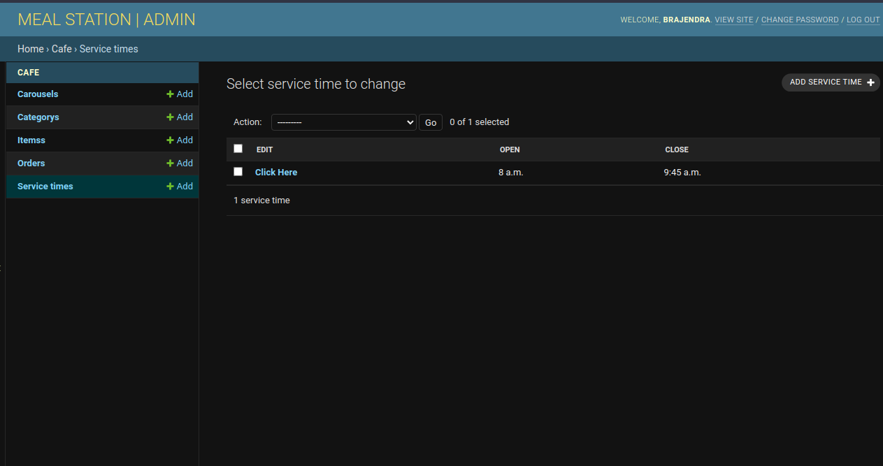
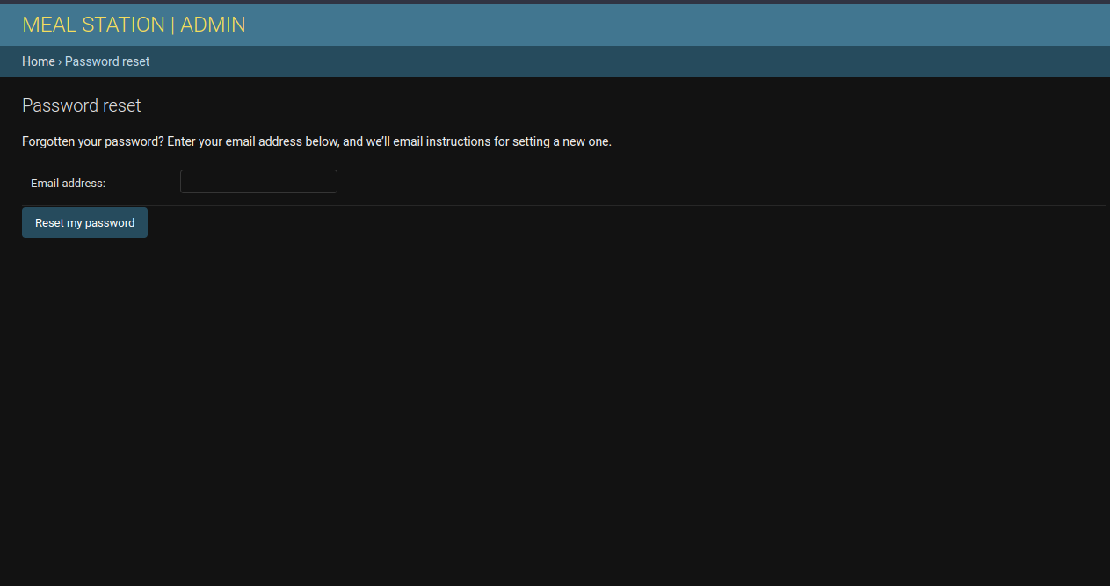
Service Time:

Admin password reset:
User Area :
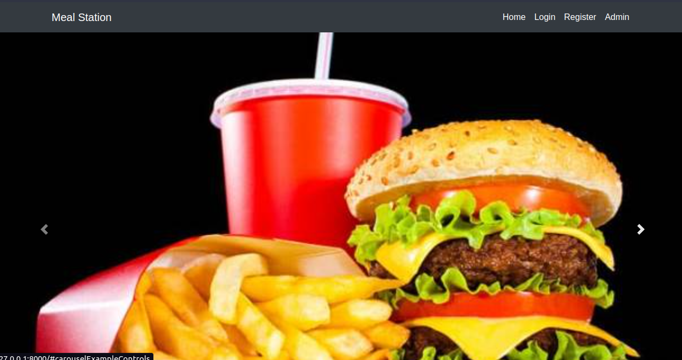
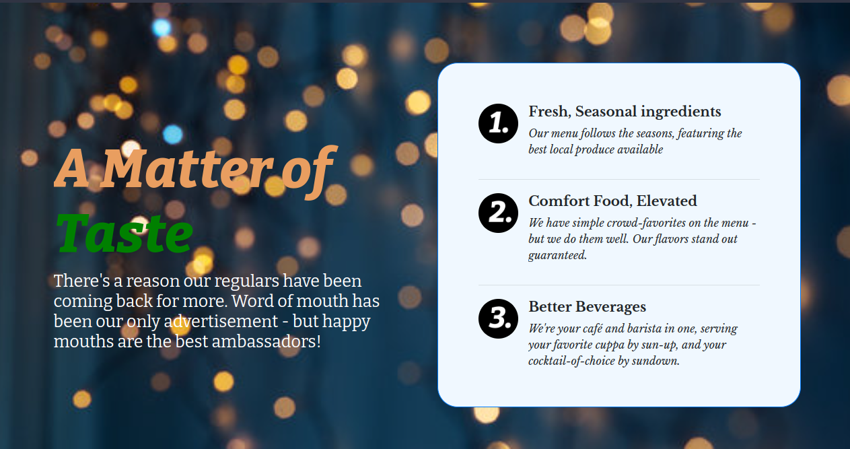
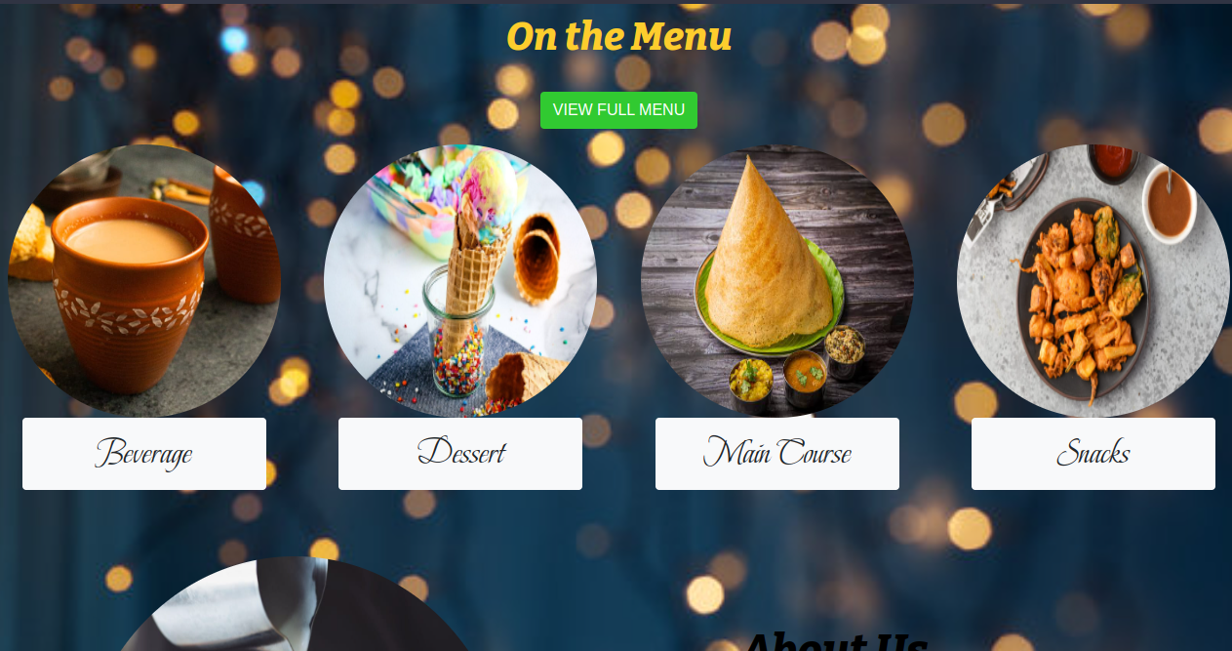
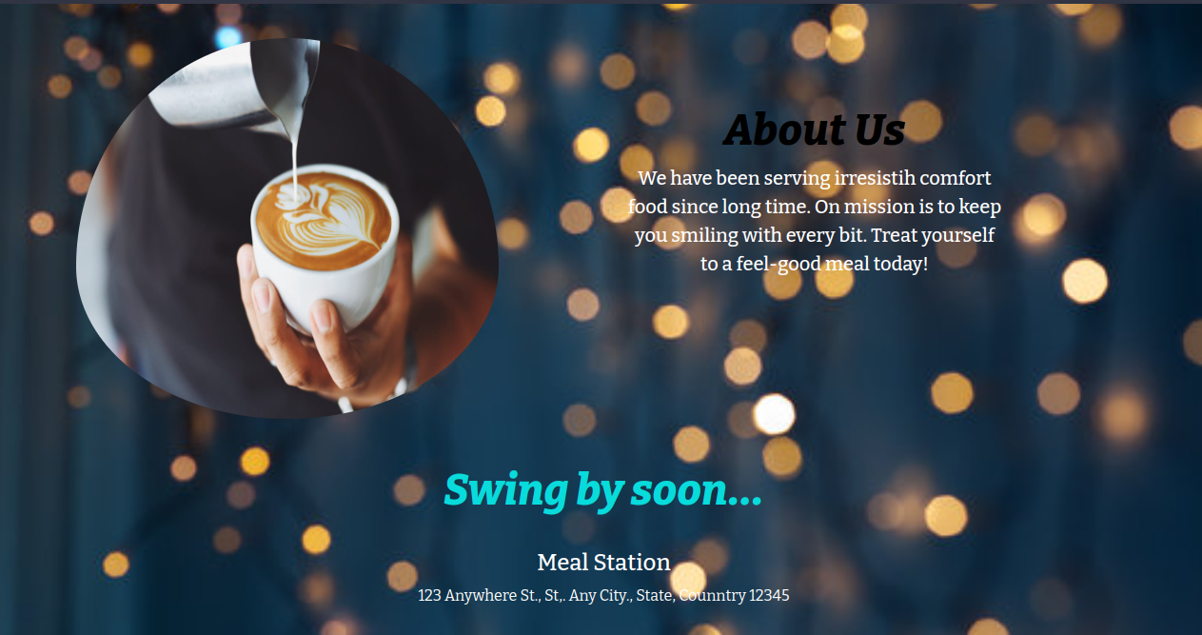
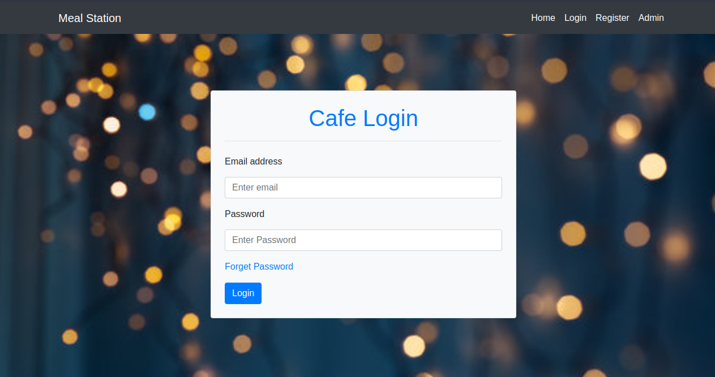
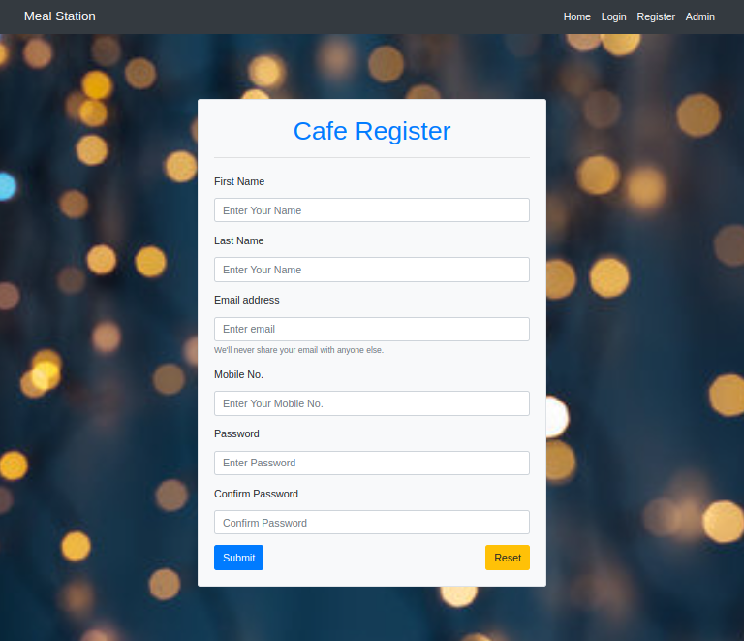
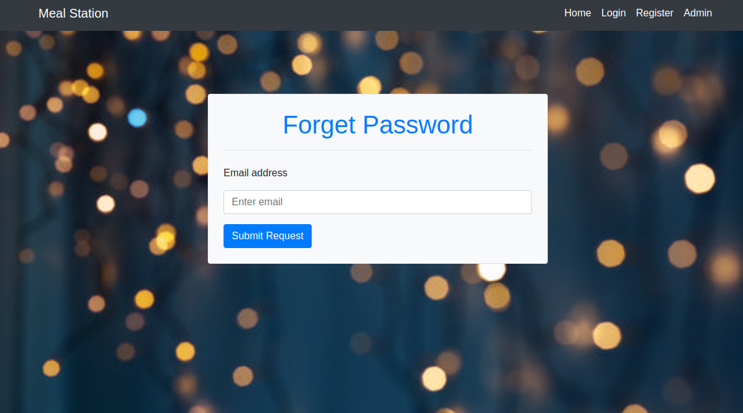
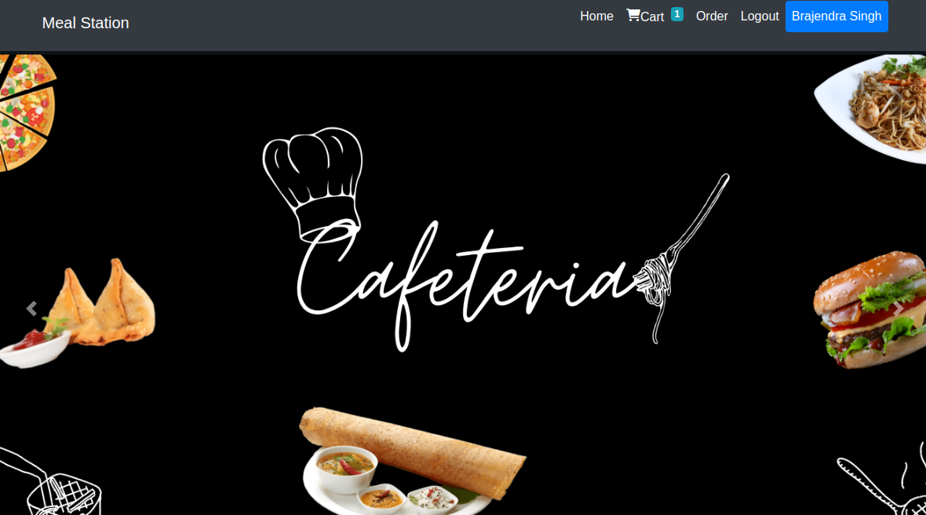
After User Login
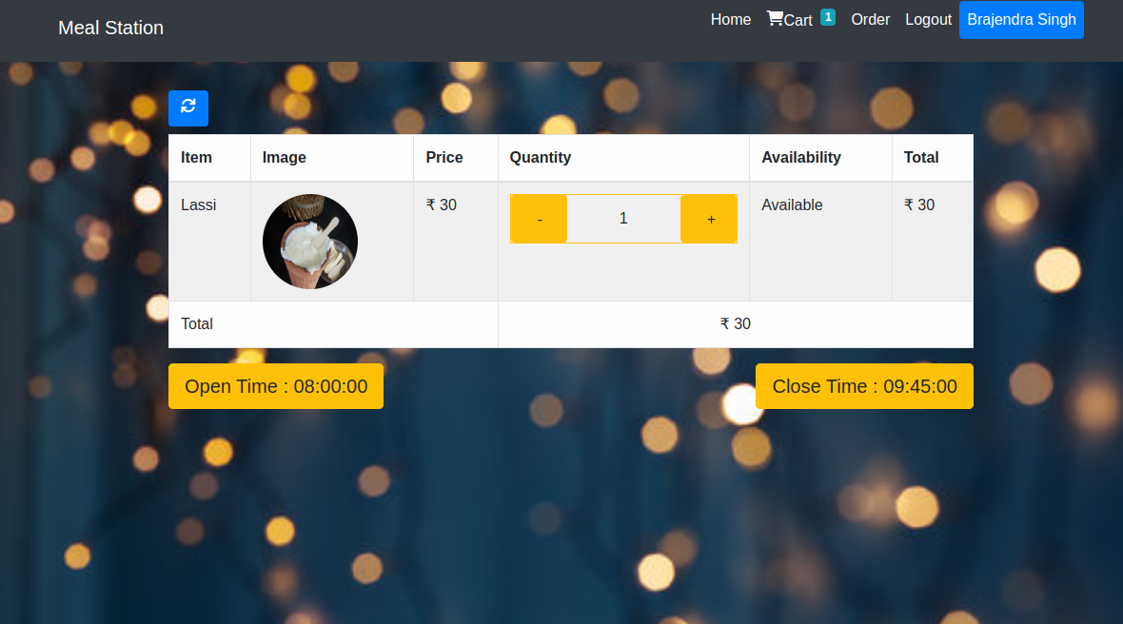
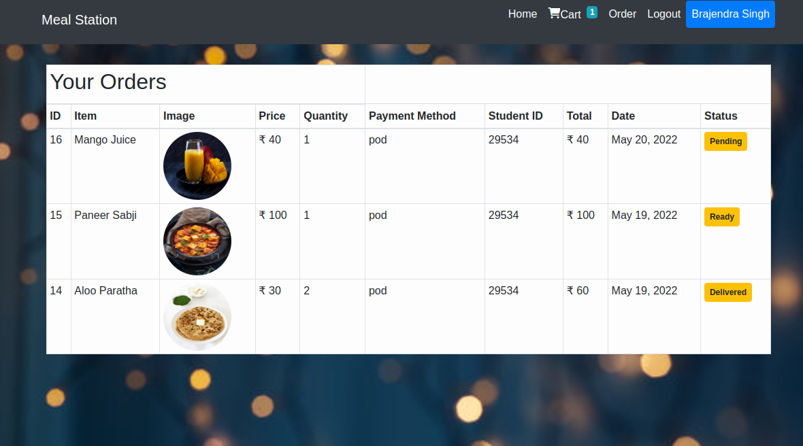
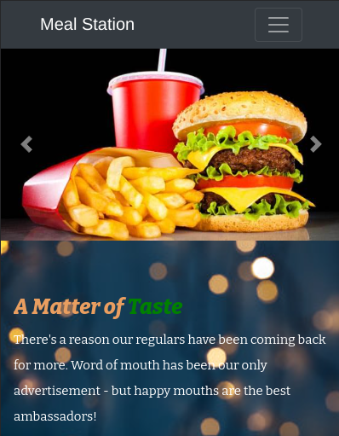
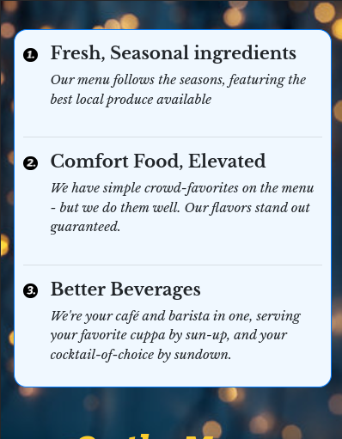
Mobile View:
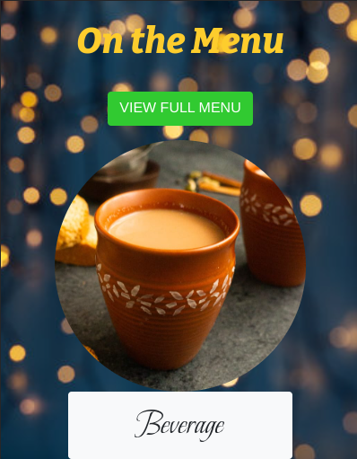



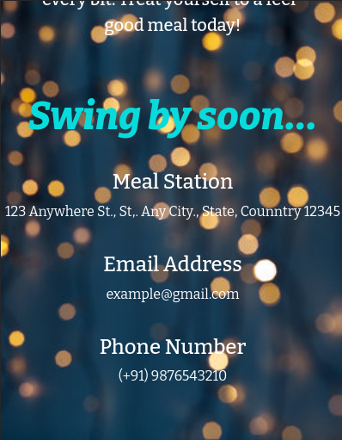
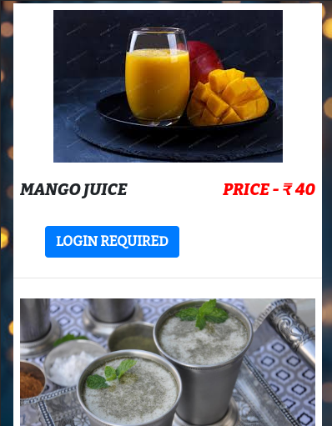
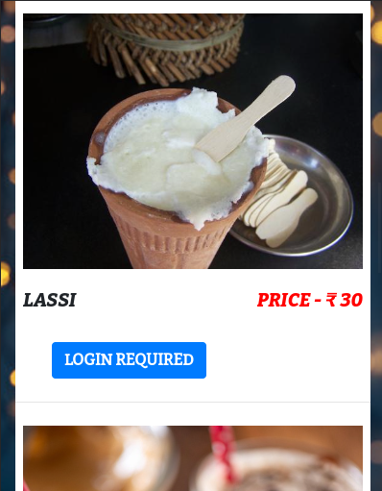
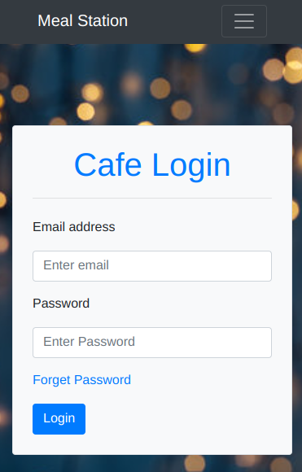
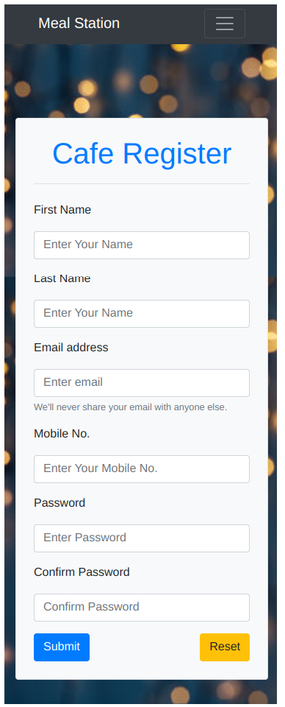
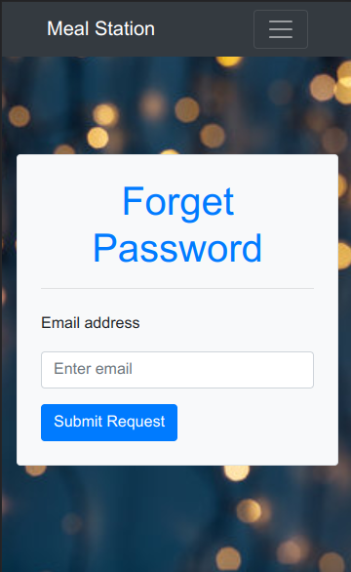
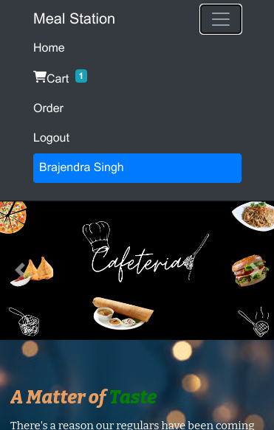
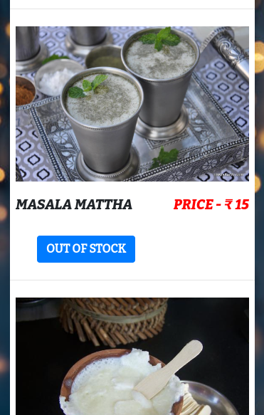
Mobile view after login:
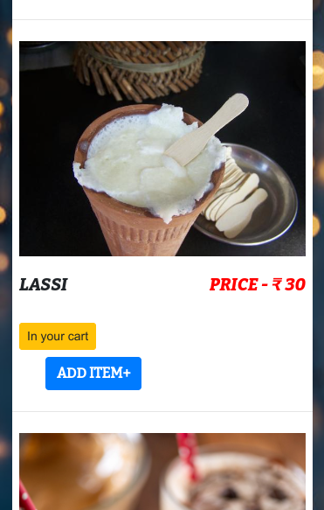
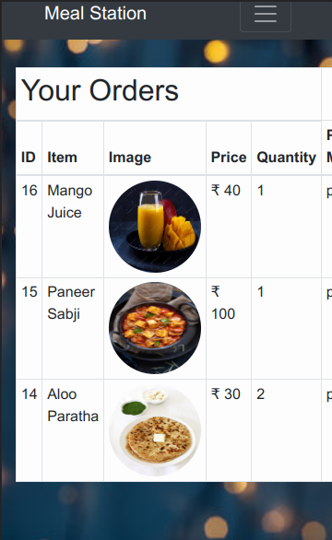

Conclusion

- The development of Canteen Management System involved many phases. The approach used is a top-down one concentrating on what first then how and moving to successive levels of details.
- The first phase started with a detailed study of the problems and prospects of ordering in Foods.
- This Software is efficient in maintaining customer’s details and can easily perform operations on platform.

References

- Google and Stack Overflow for problem solving
- https://html5.org/
- https://www.w3.org/Style/CSS/Overview.en.html
- https://getbootstrap.com/docs/4.0/getting-started/introduction/
- https://www.python.org/
- https://www.djangoproject.com/
- https://www.javatpoint.com/
- https://en.wikipedia.org/
- https://www.youtube.com

